static: block, variable, method

instance : block, variable, method

final:

1) variables: Value cannot be changed once it is initialized.

a) Local variable: shud be initialized before it is used

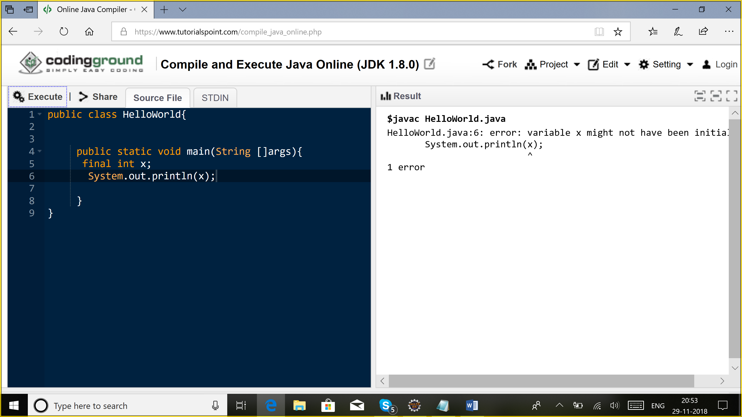

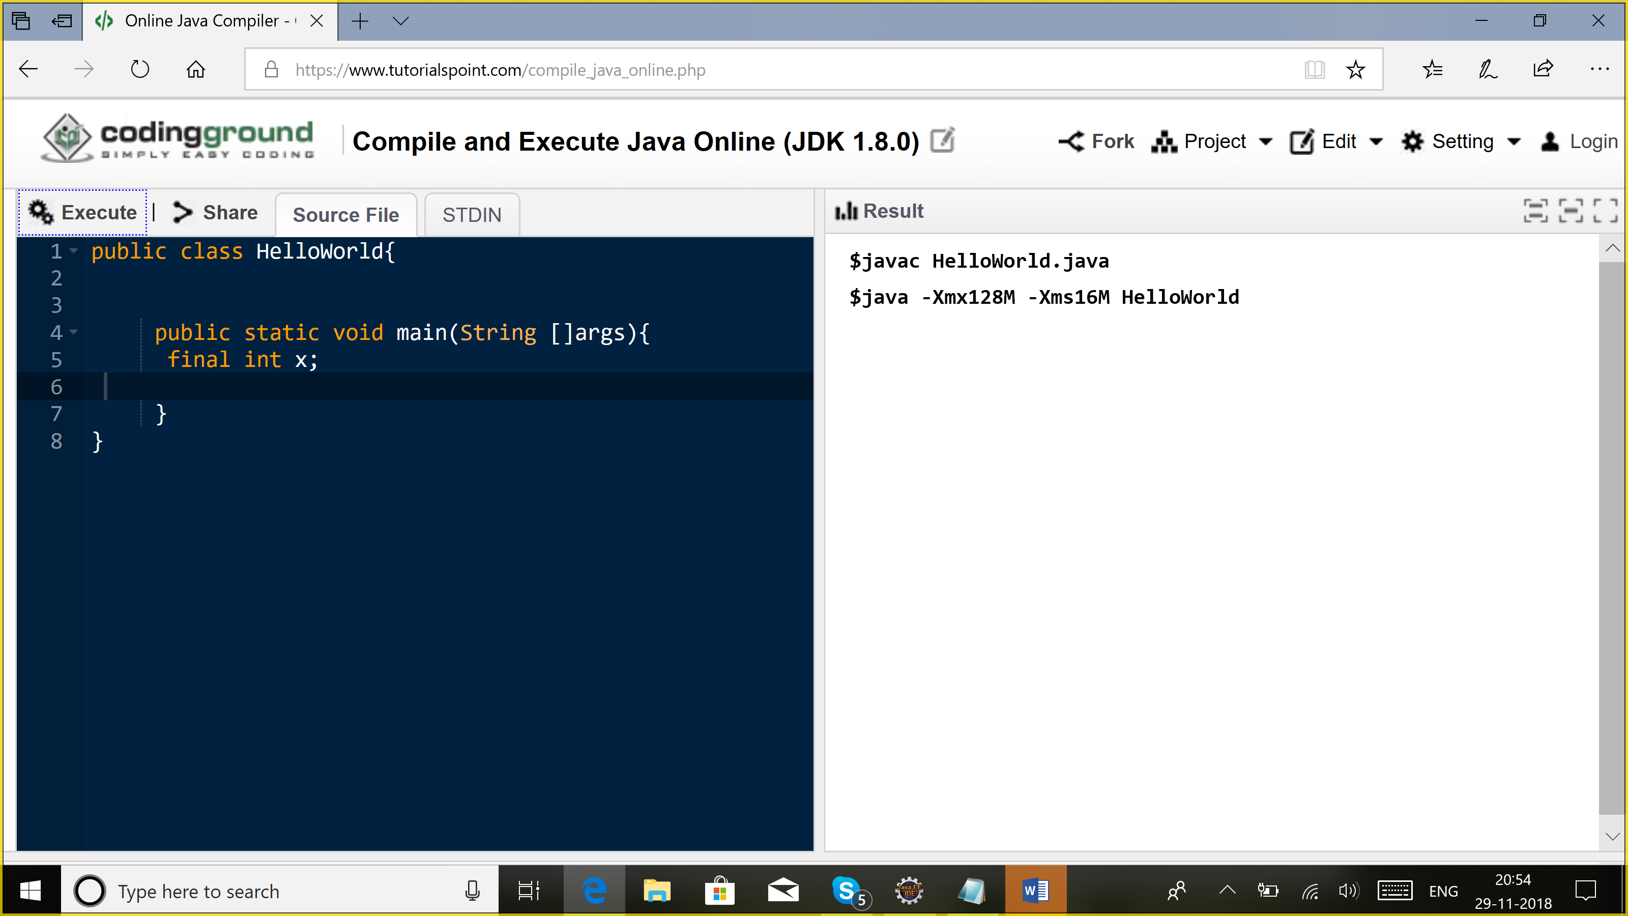

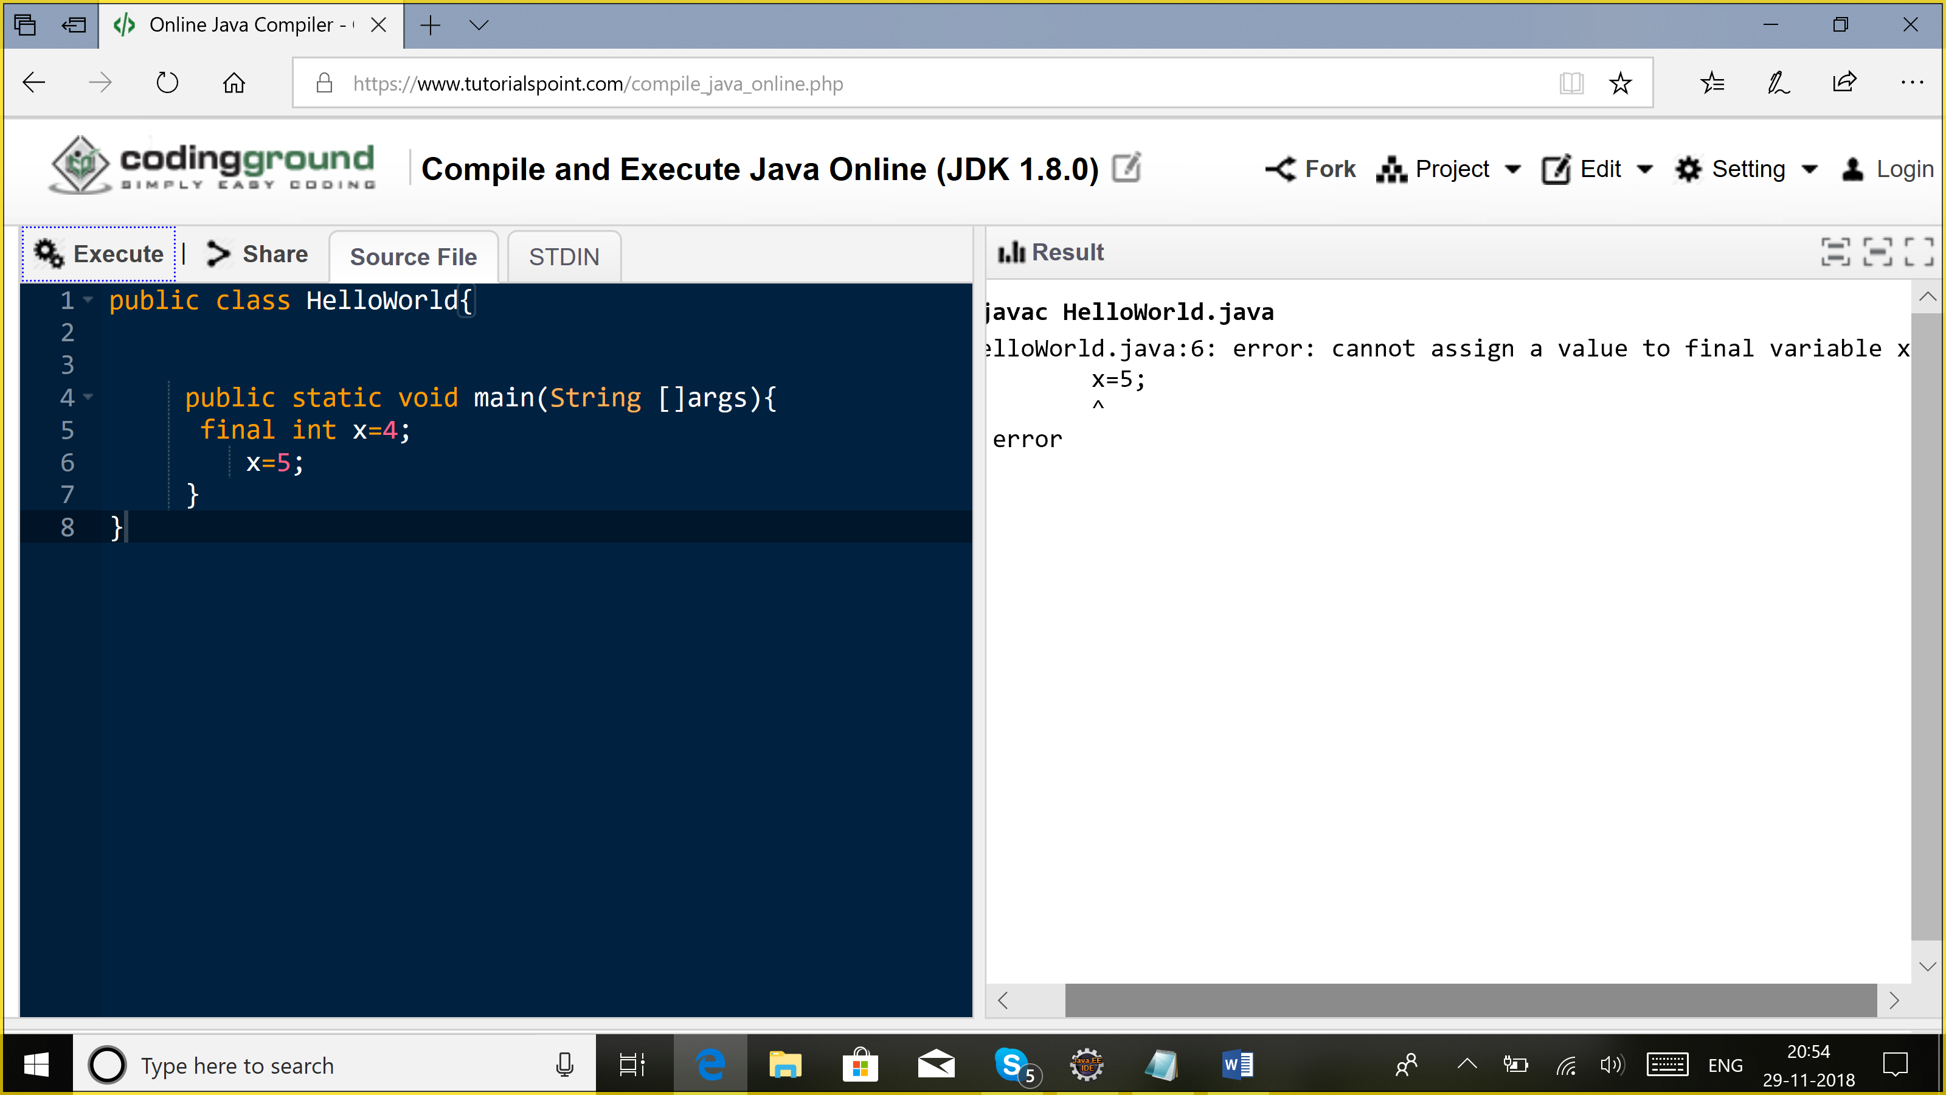

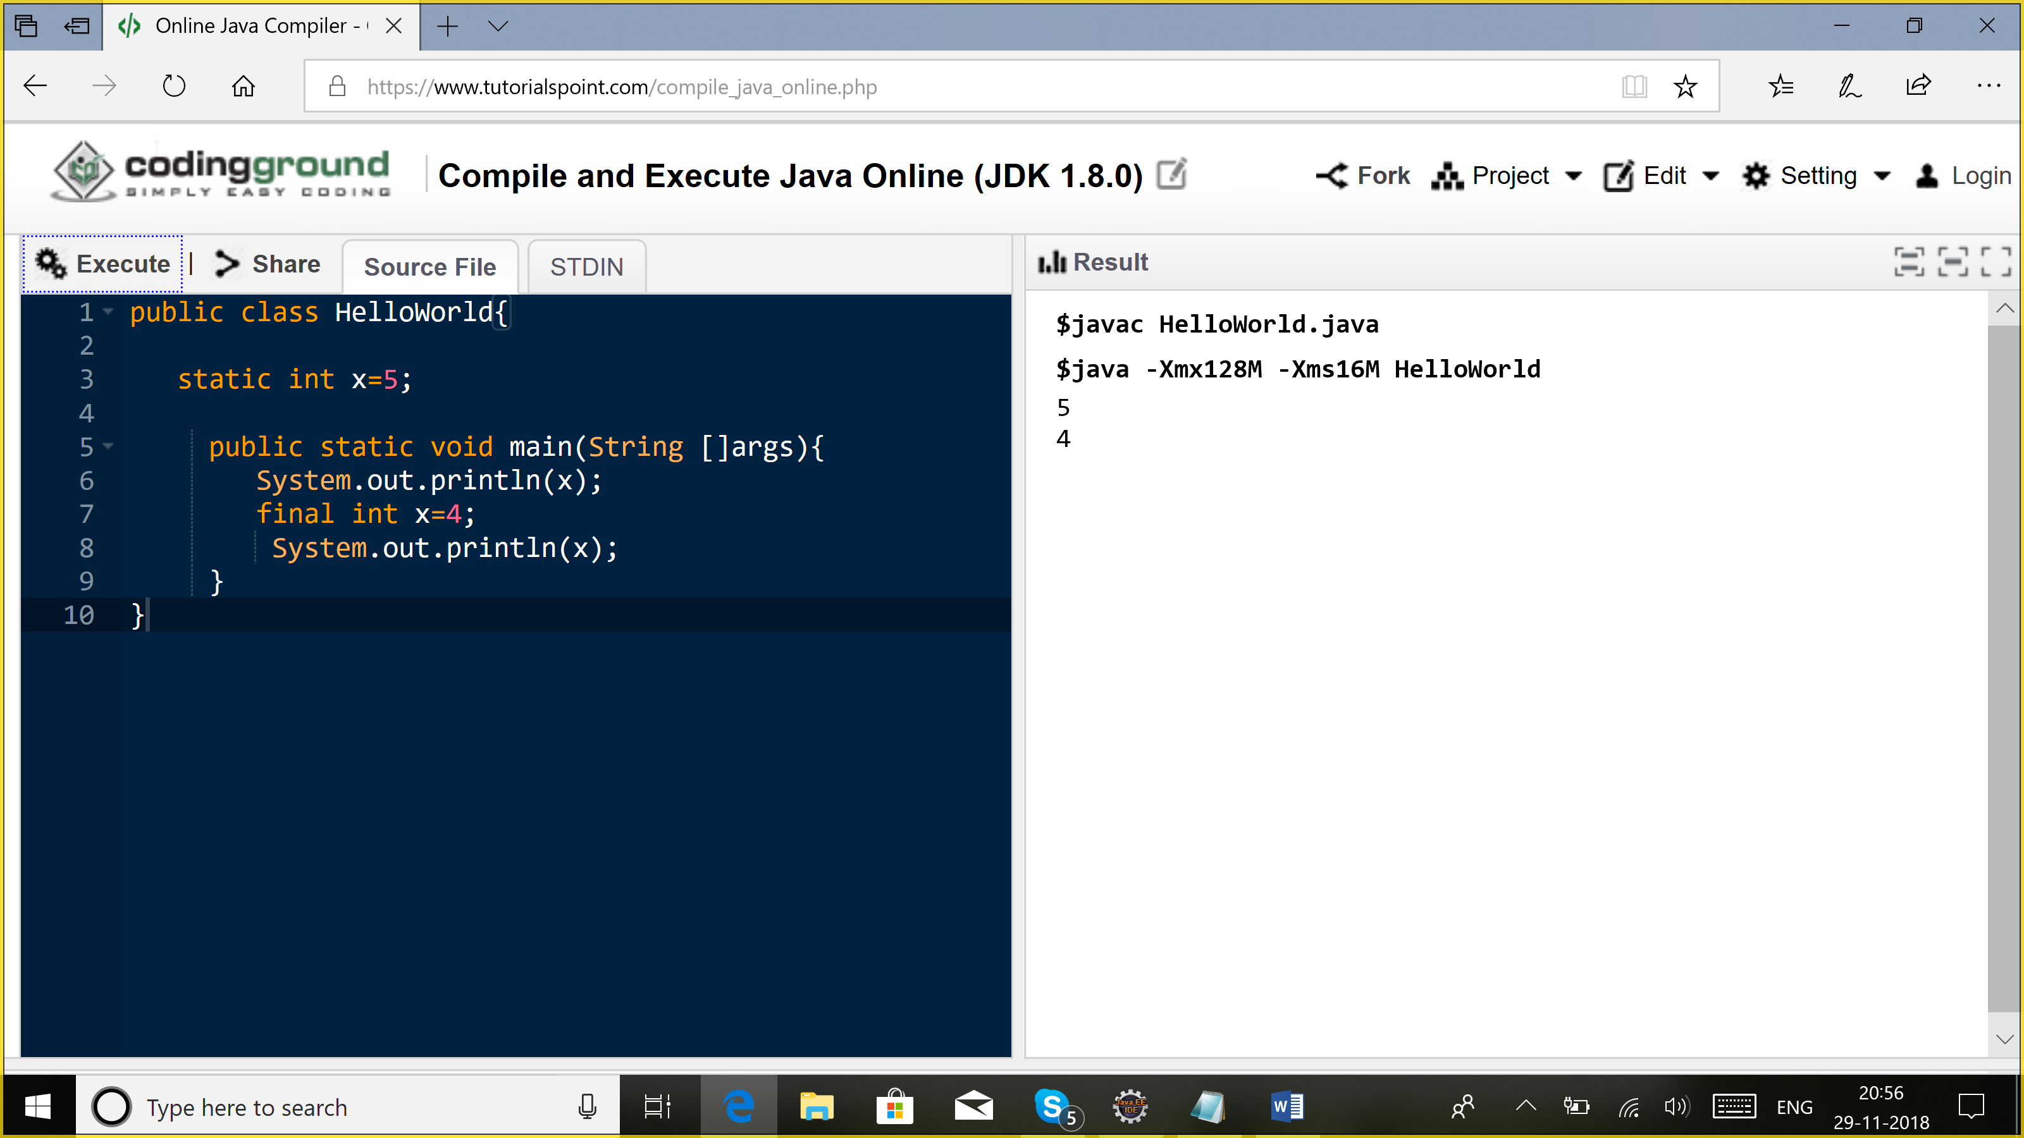

b) instance variable: Should be initialized before an object is created.

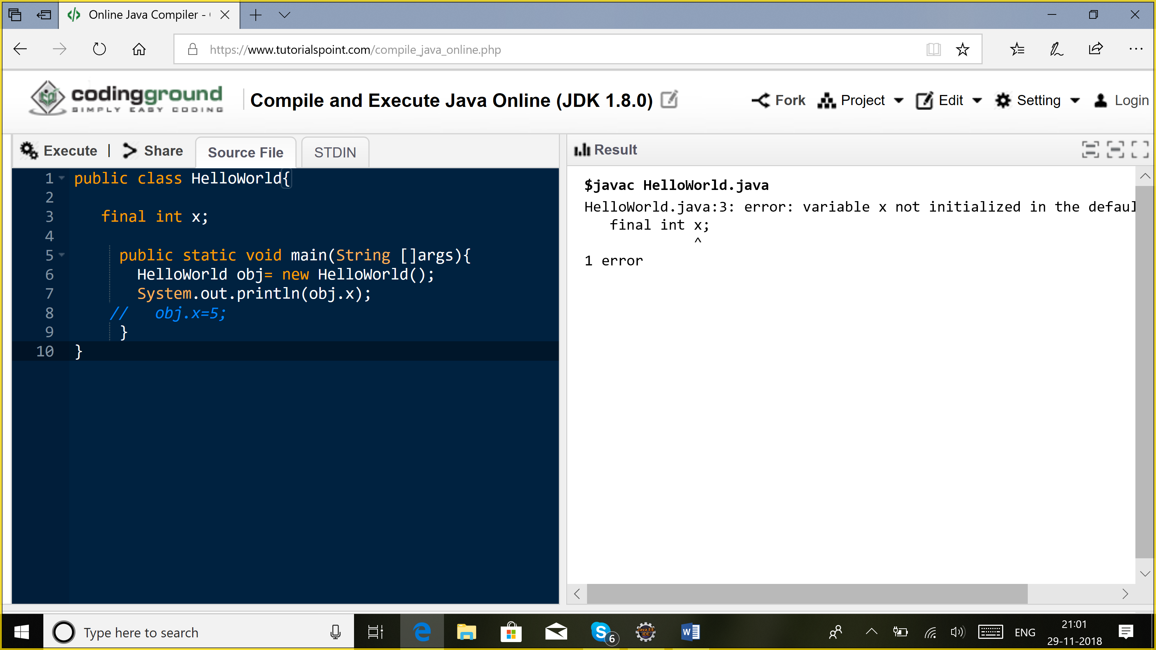

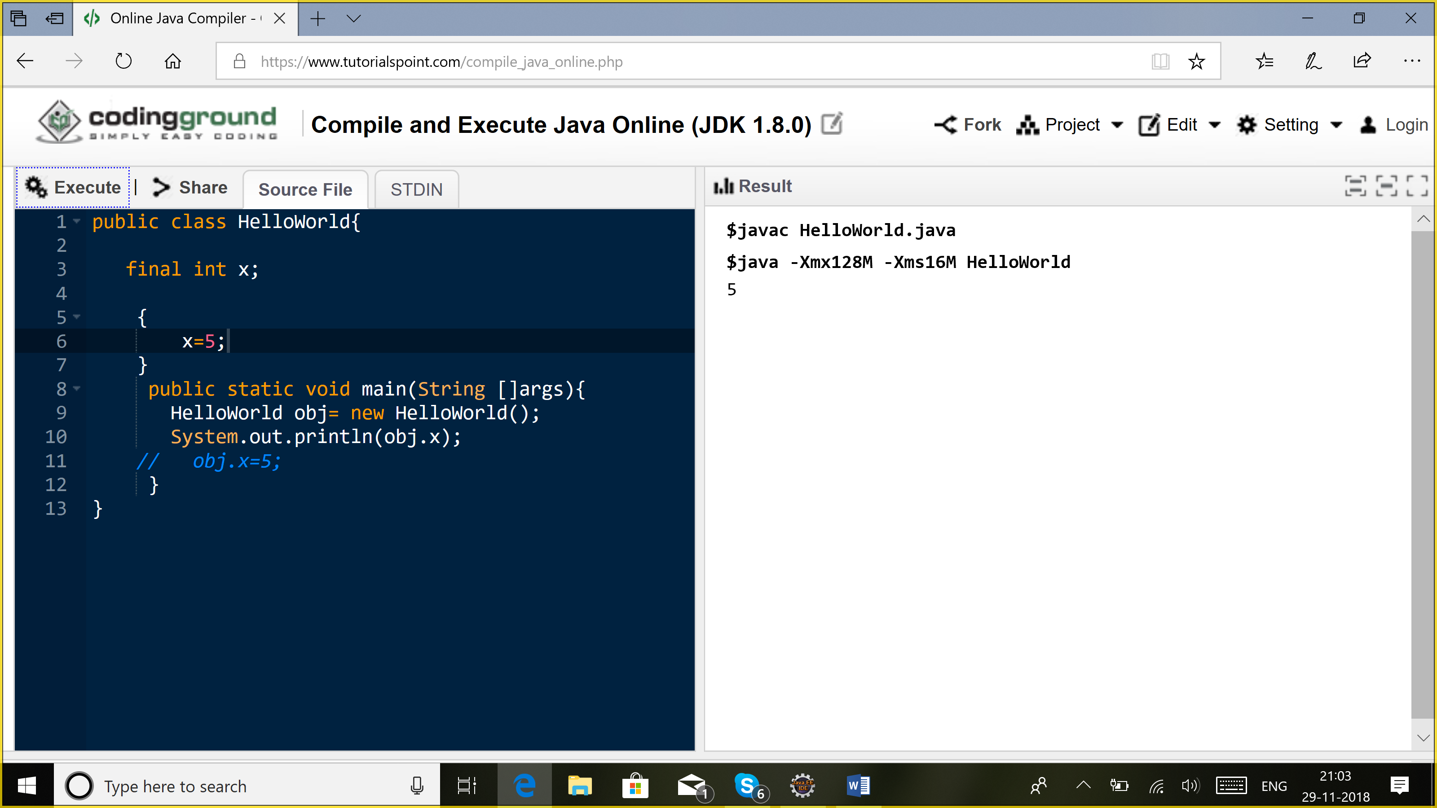

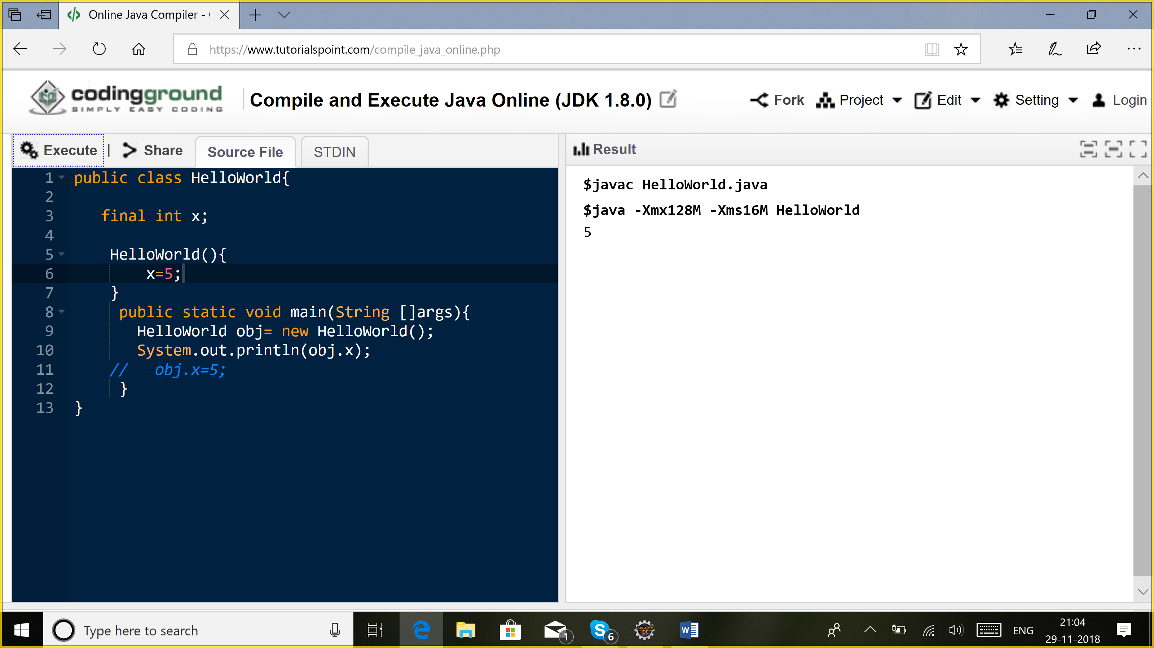

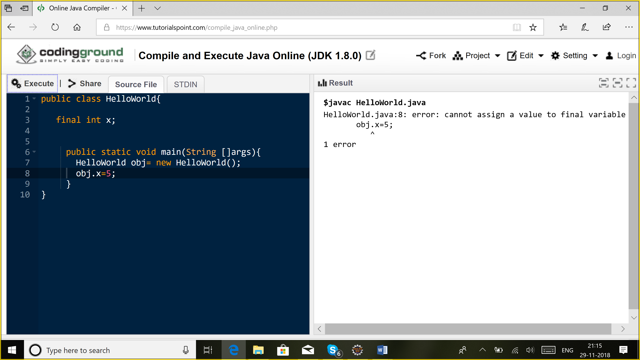

c) static variable: It should be initialized before the class is loaded.

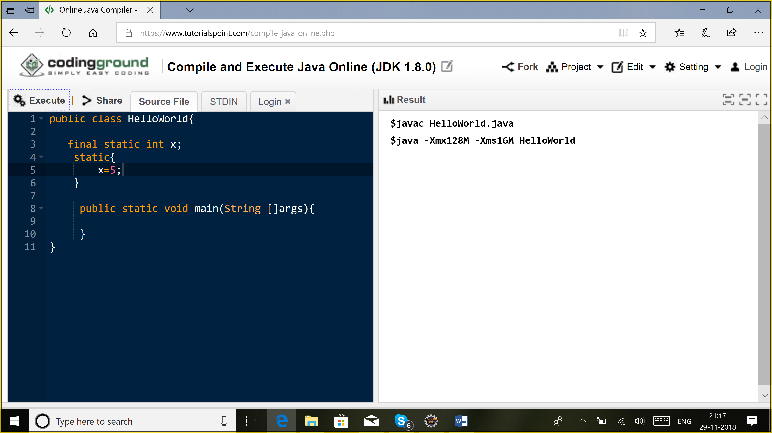

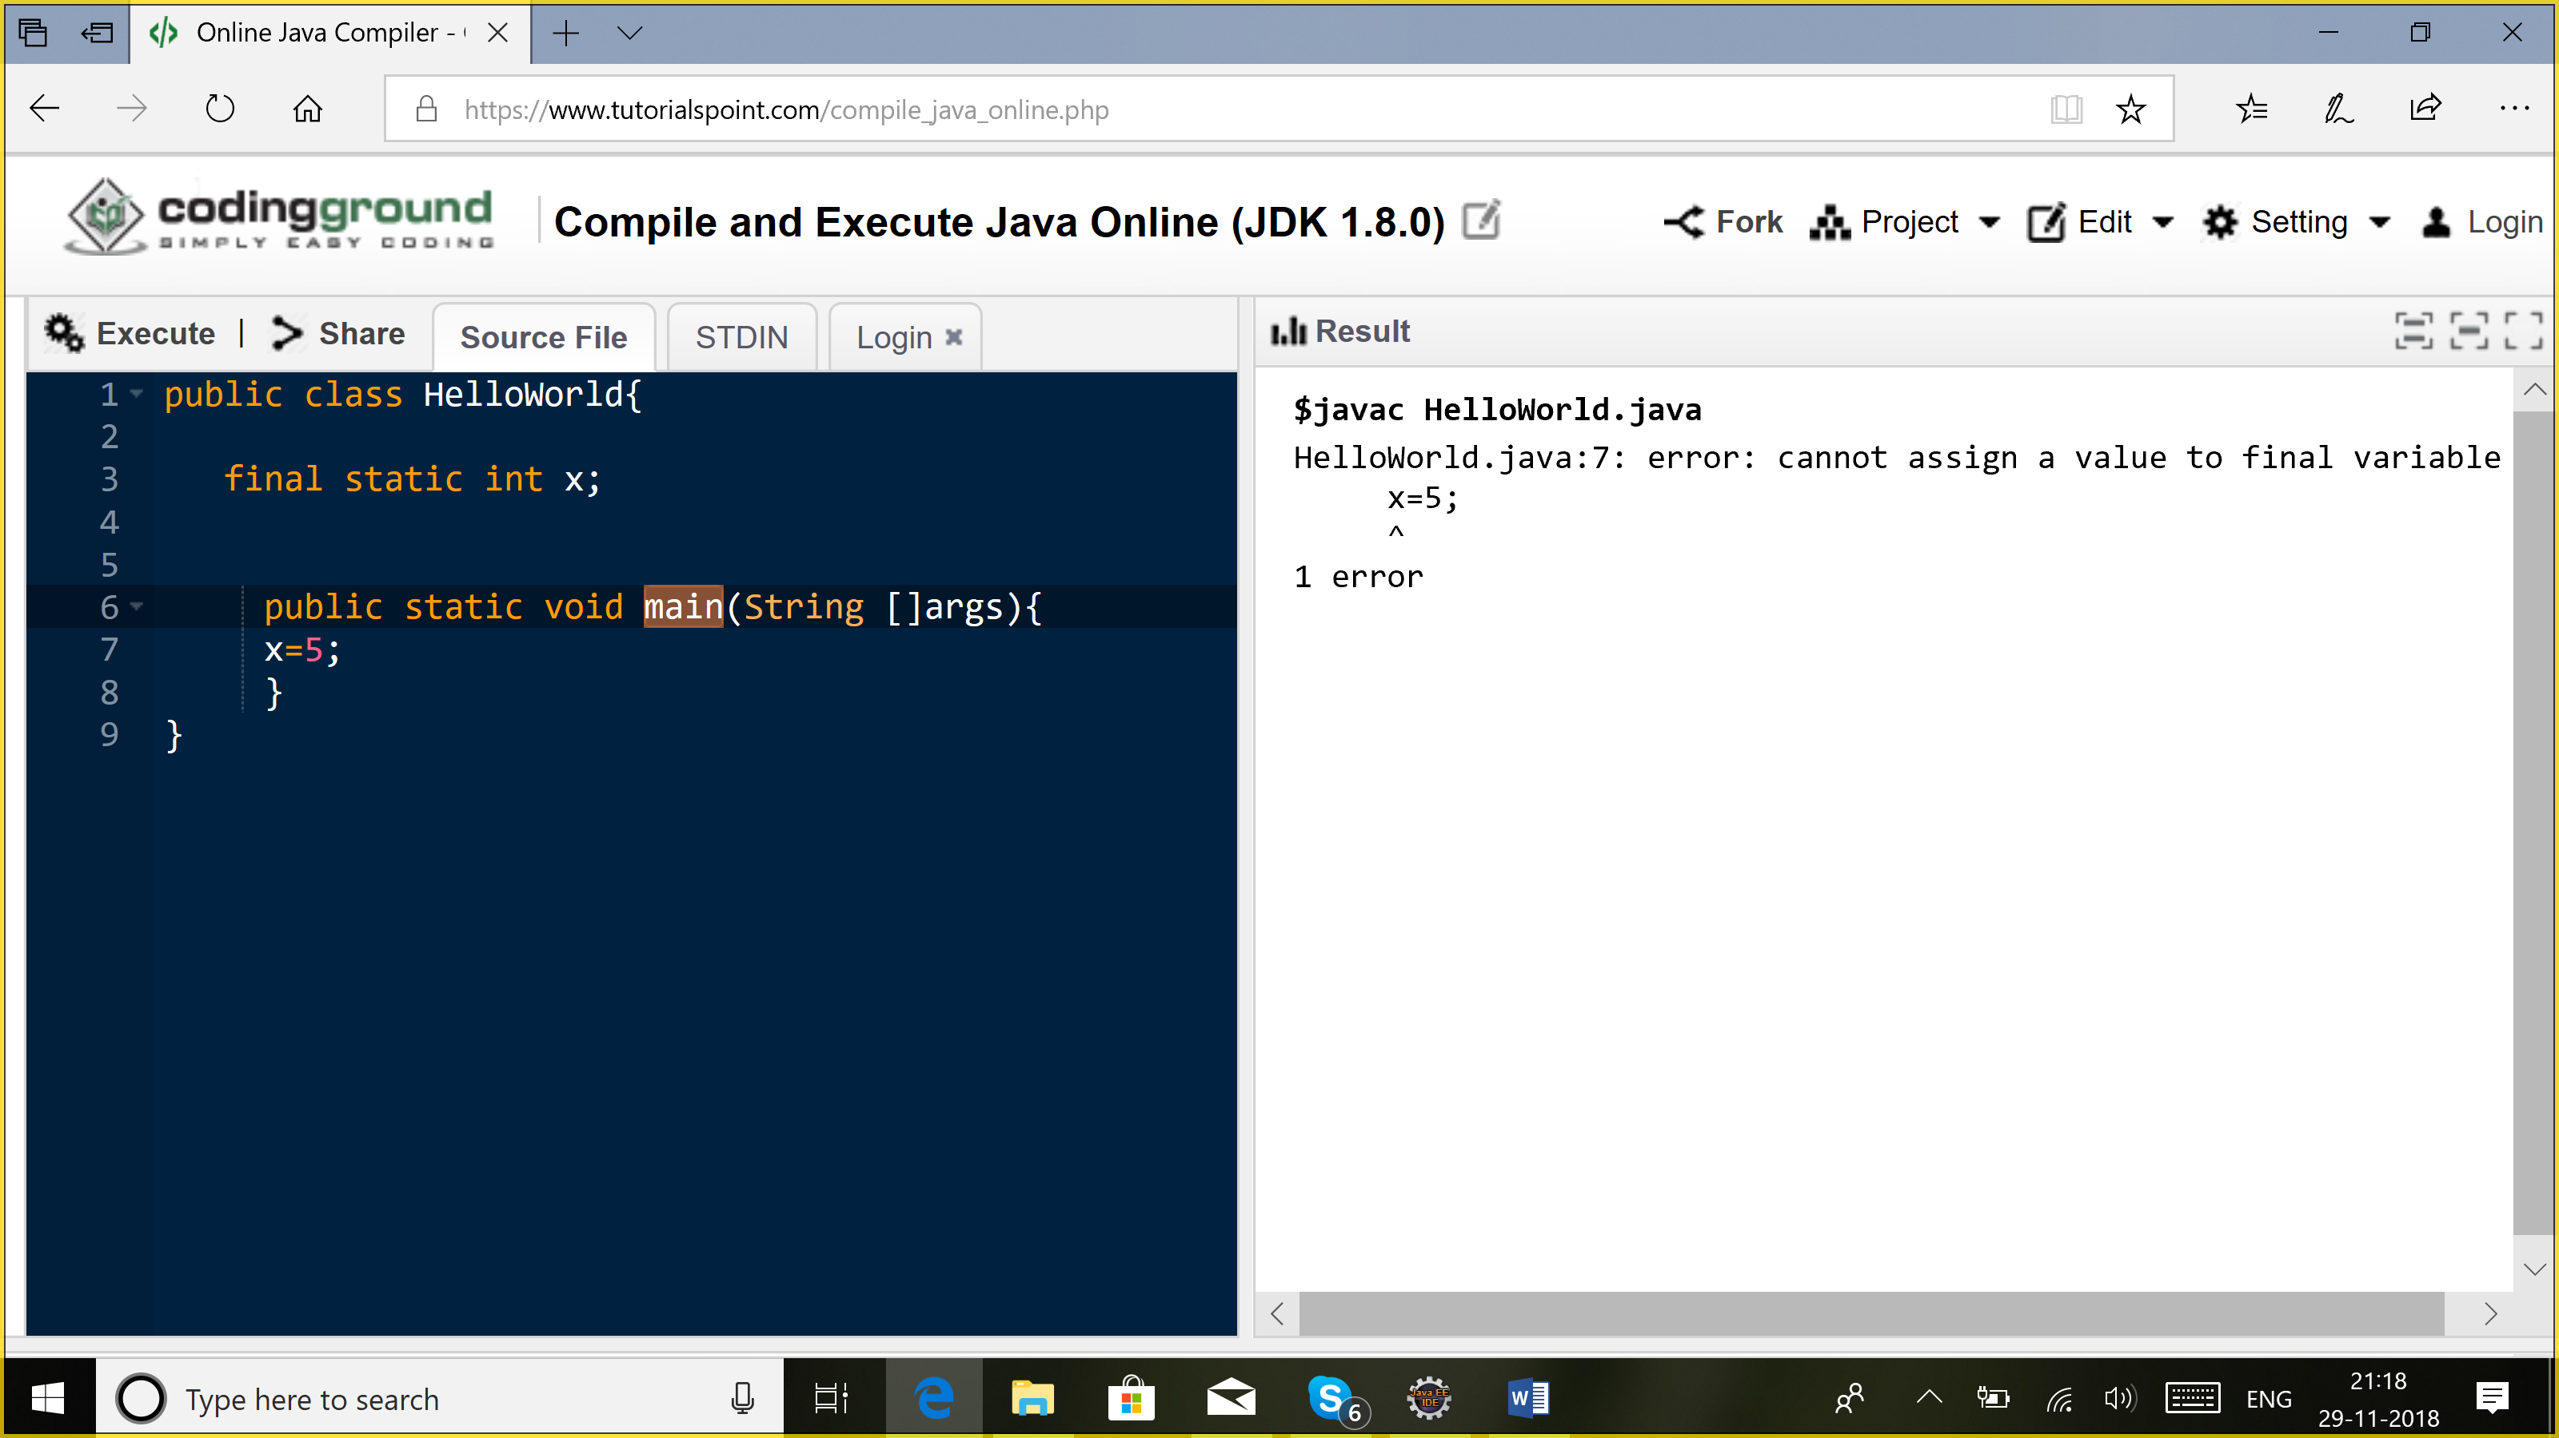

2) method: Cannot be overridden

3) class: Cannot be extended. U cannot subclass a final class

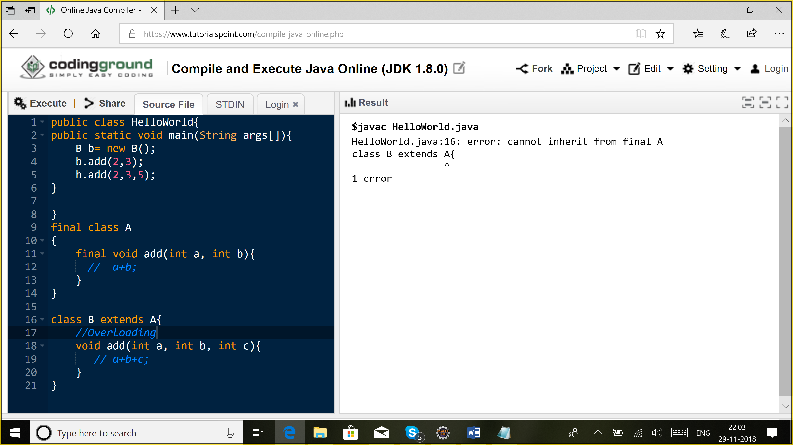

**Constructor:**

Used to create an object.

1. Same name as class
2. Constructor cannot return a value
3. U can overload constructor
4. Can have any access modifier
5. We cannot use Static keyword with a constructor
6. We cannot use Final with a constructor because constructor cannot be overridden.

We invoke a constructor by using a new keyword.

If I add my own constructor, compiler will not create a default constructor for me.

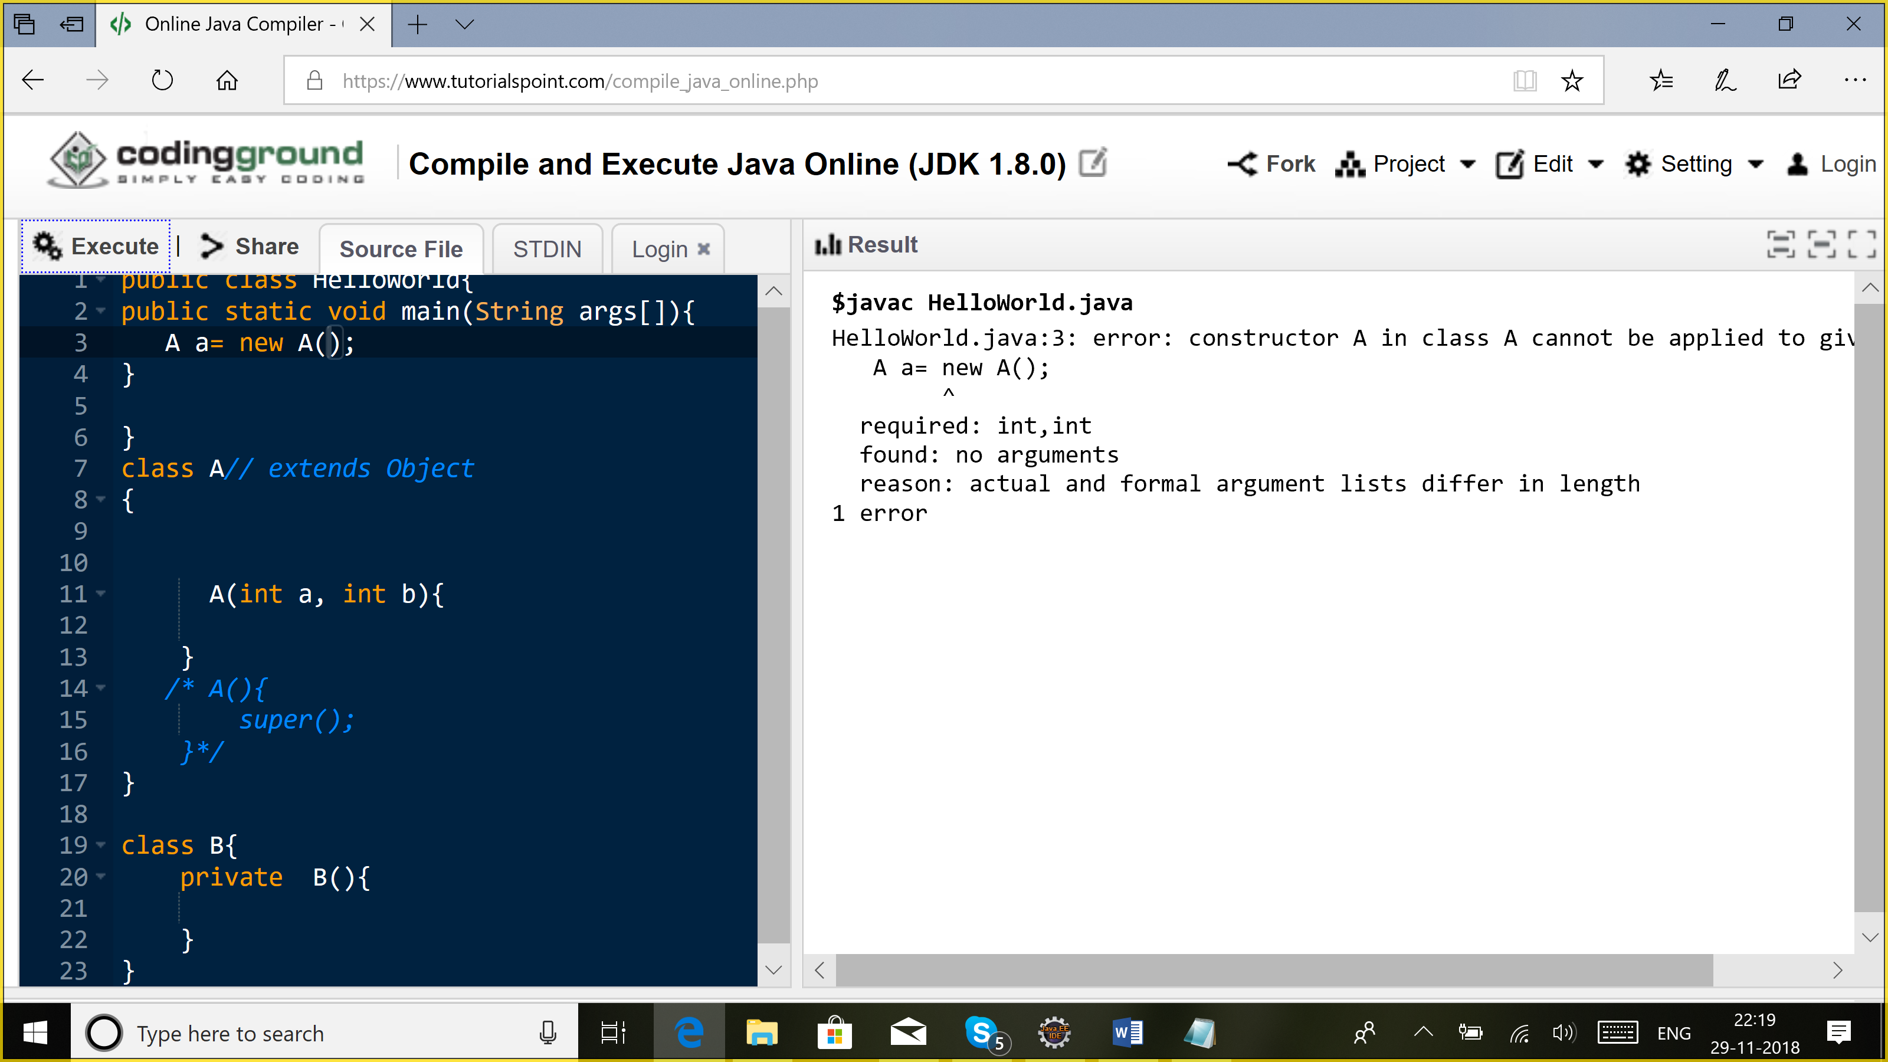

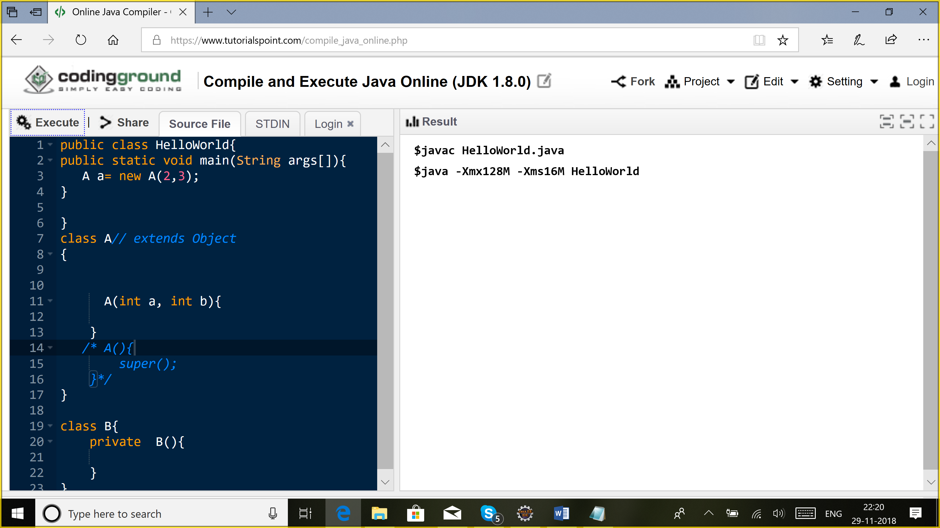

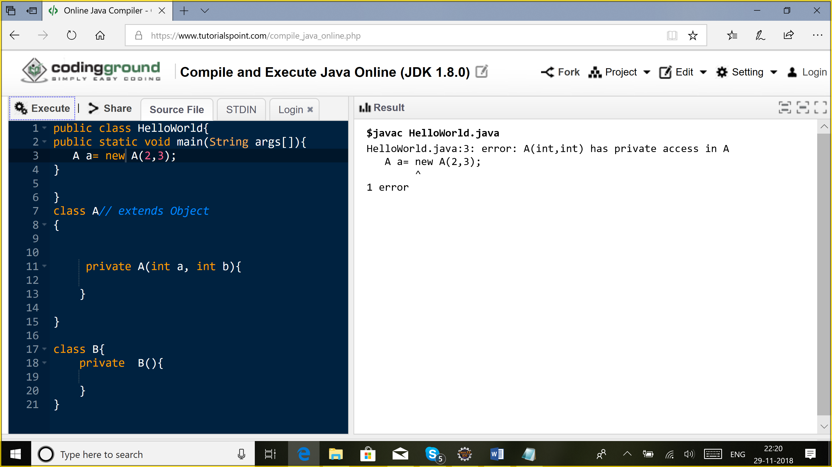

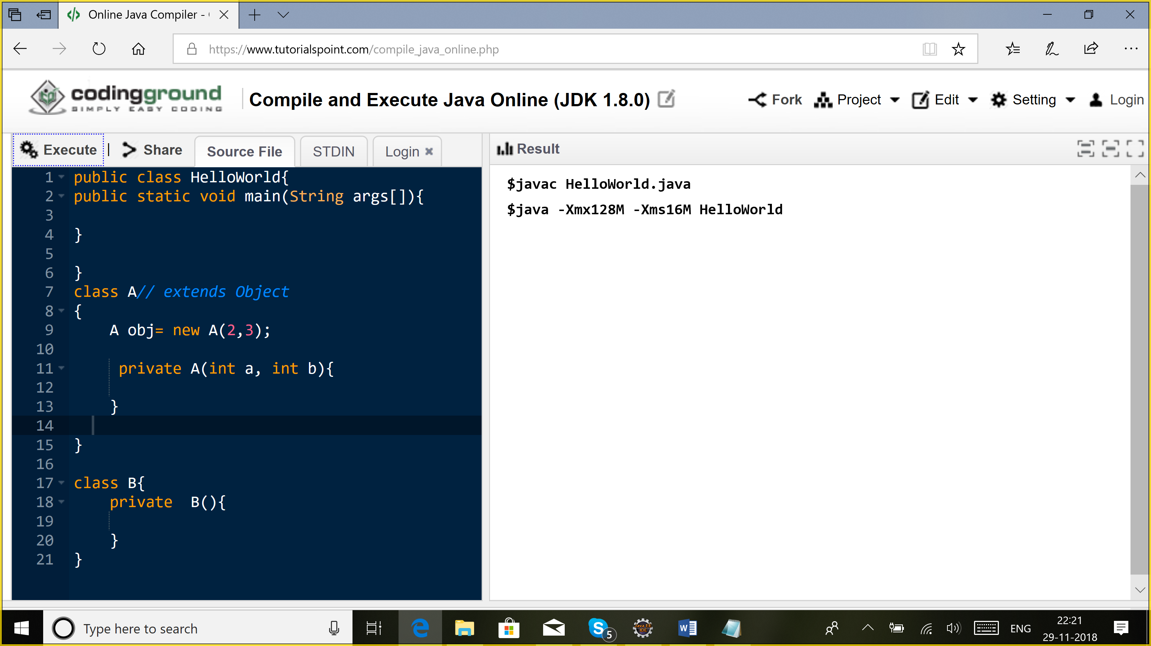

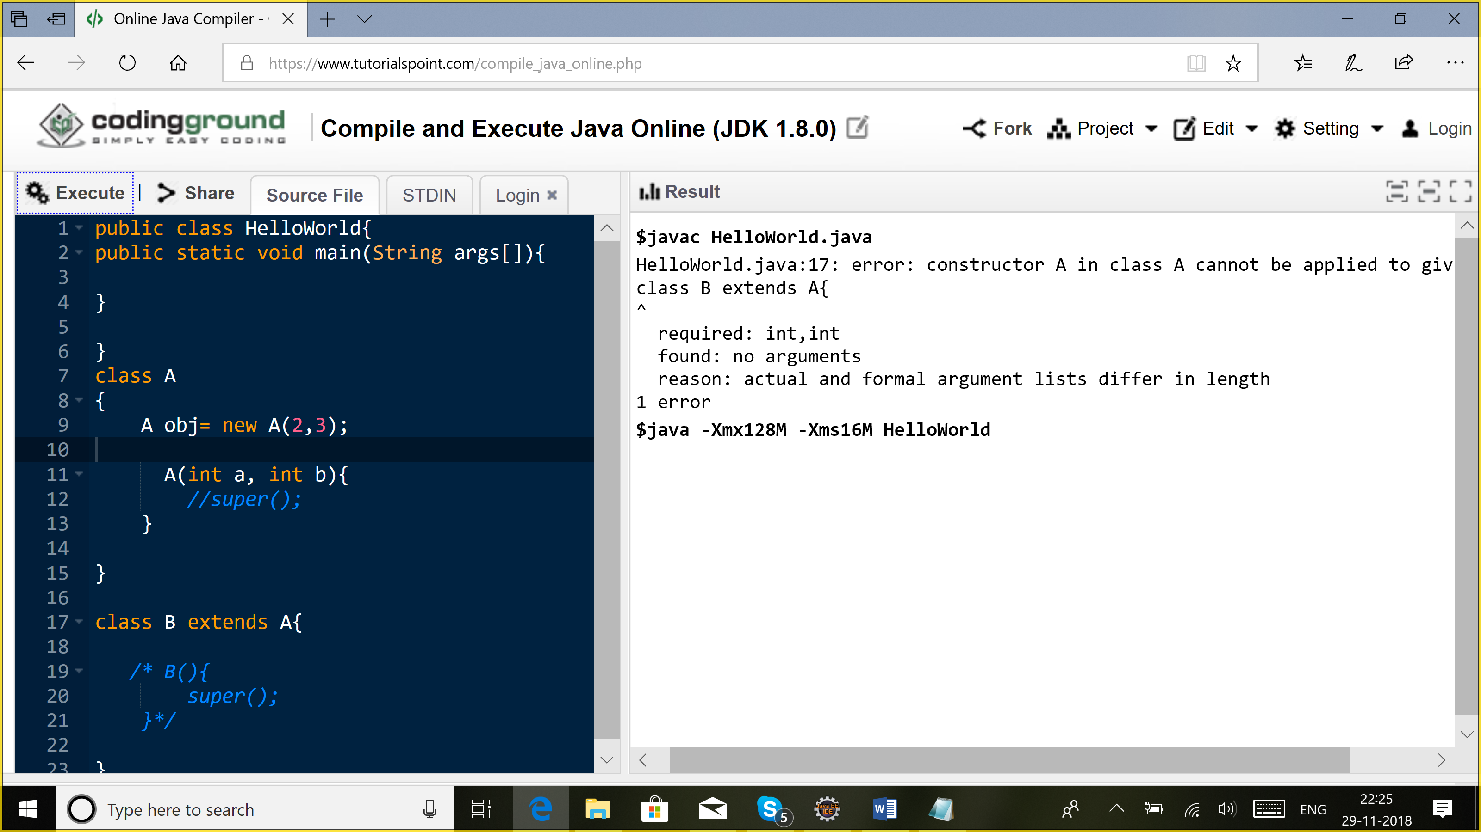

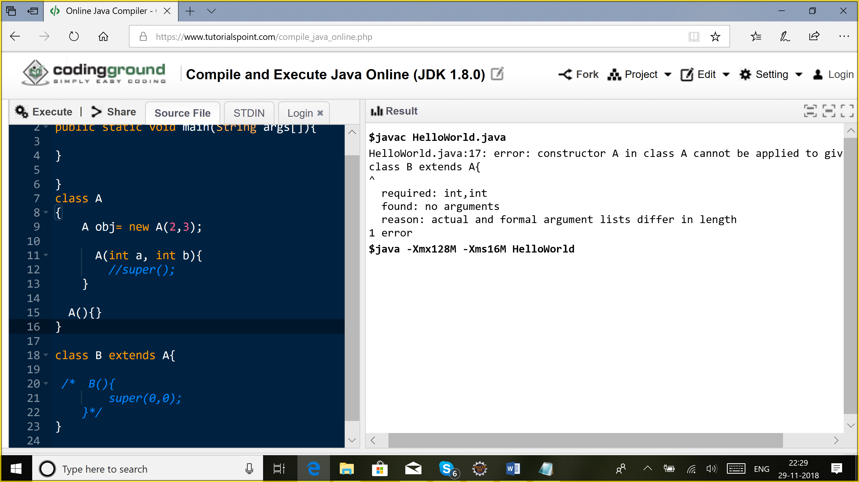

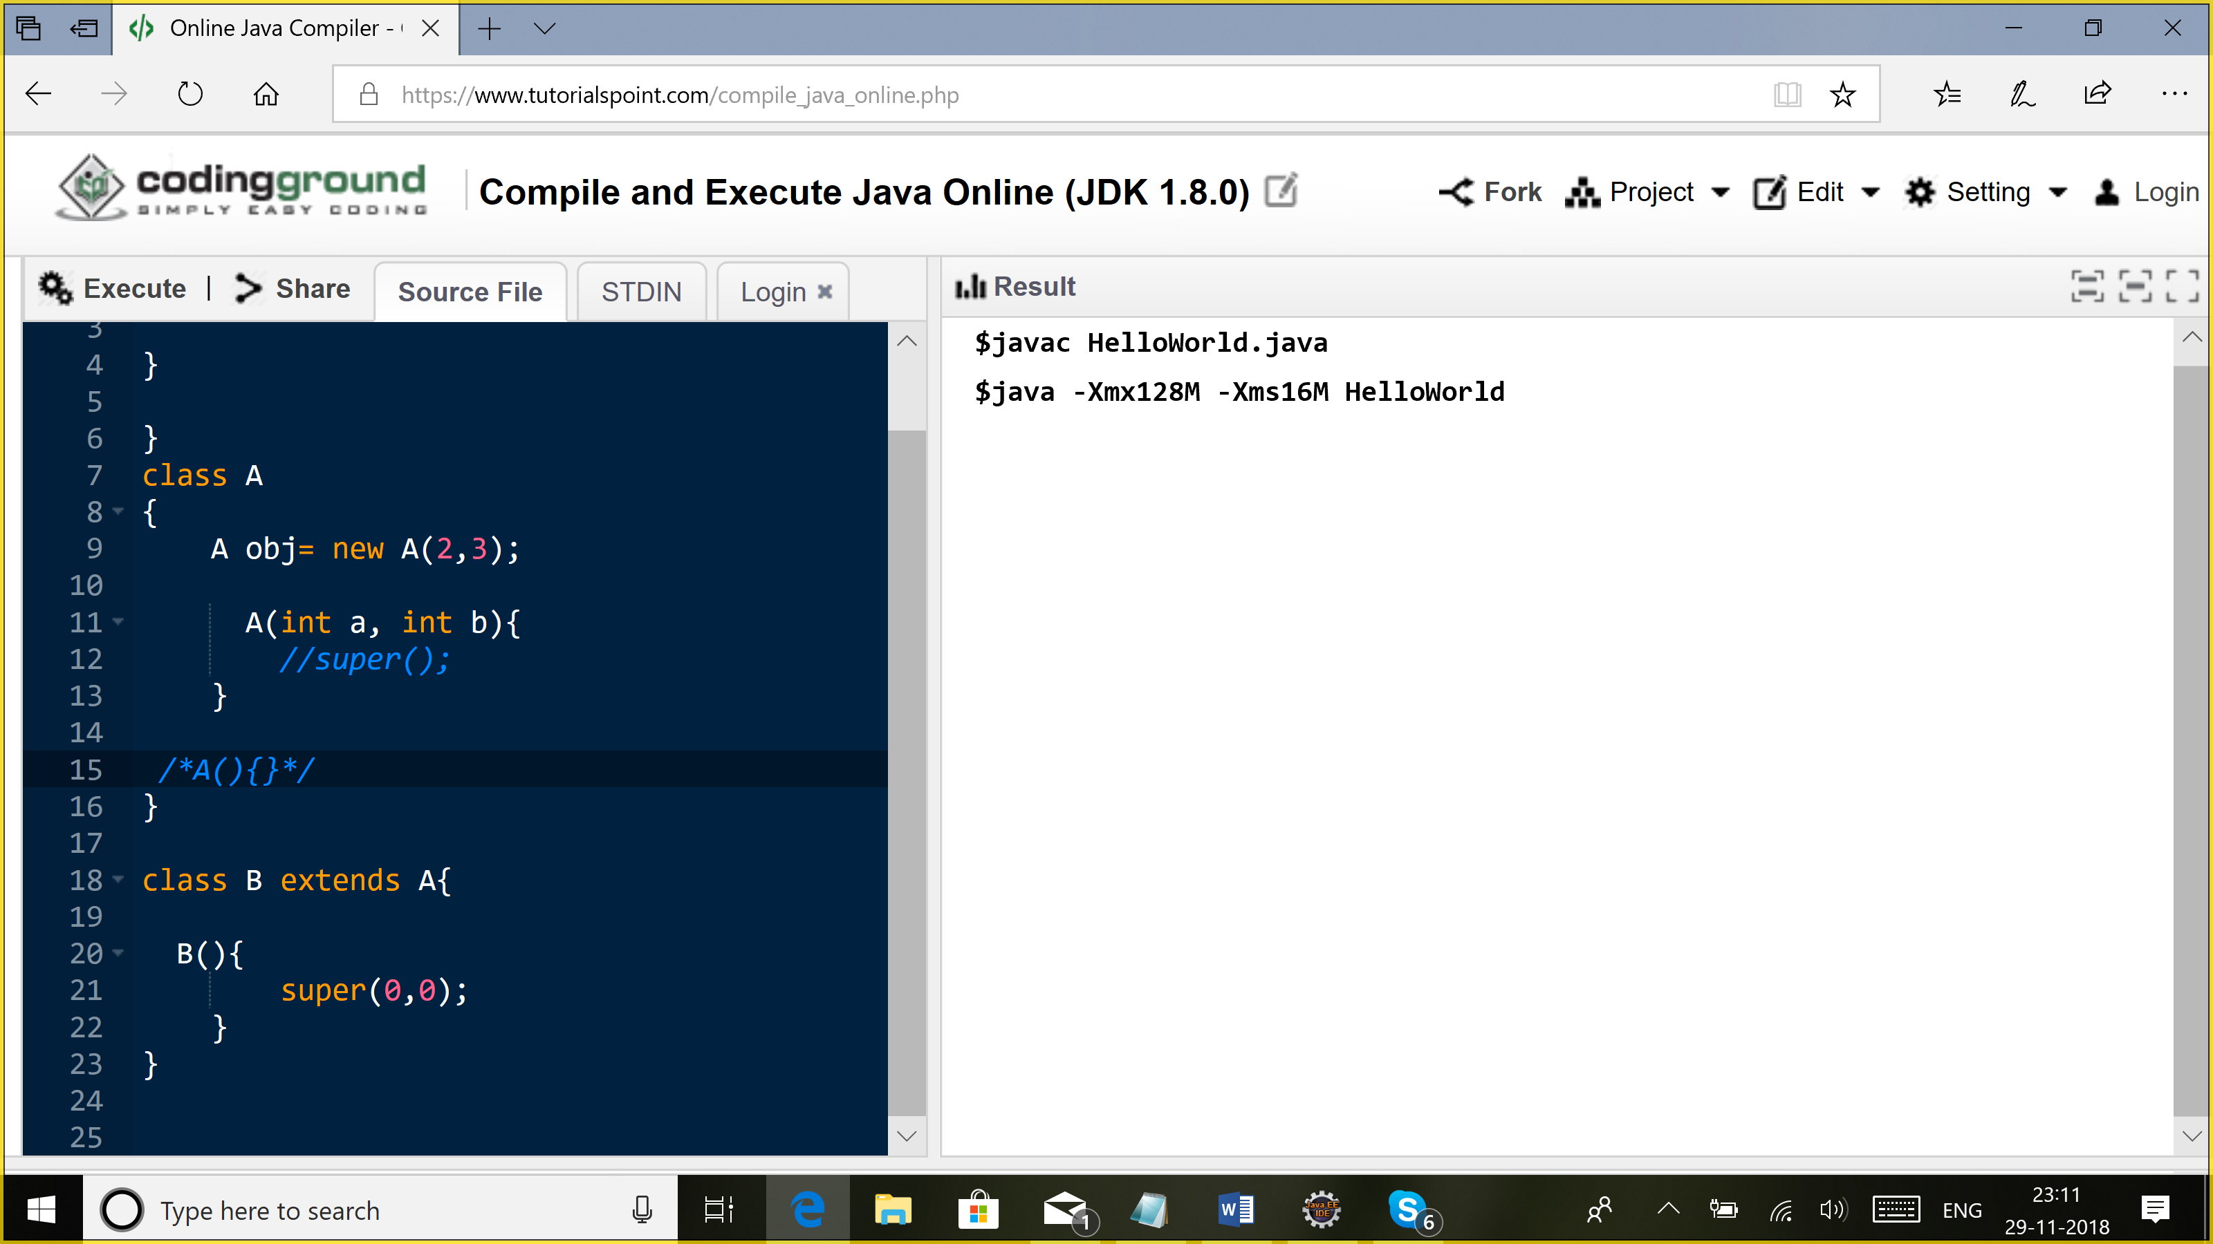

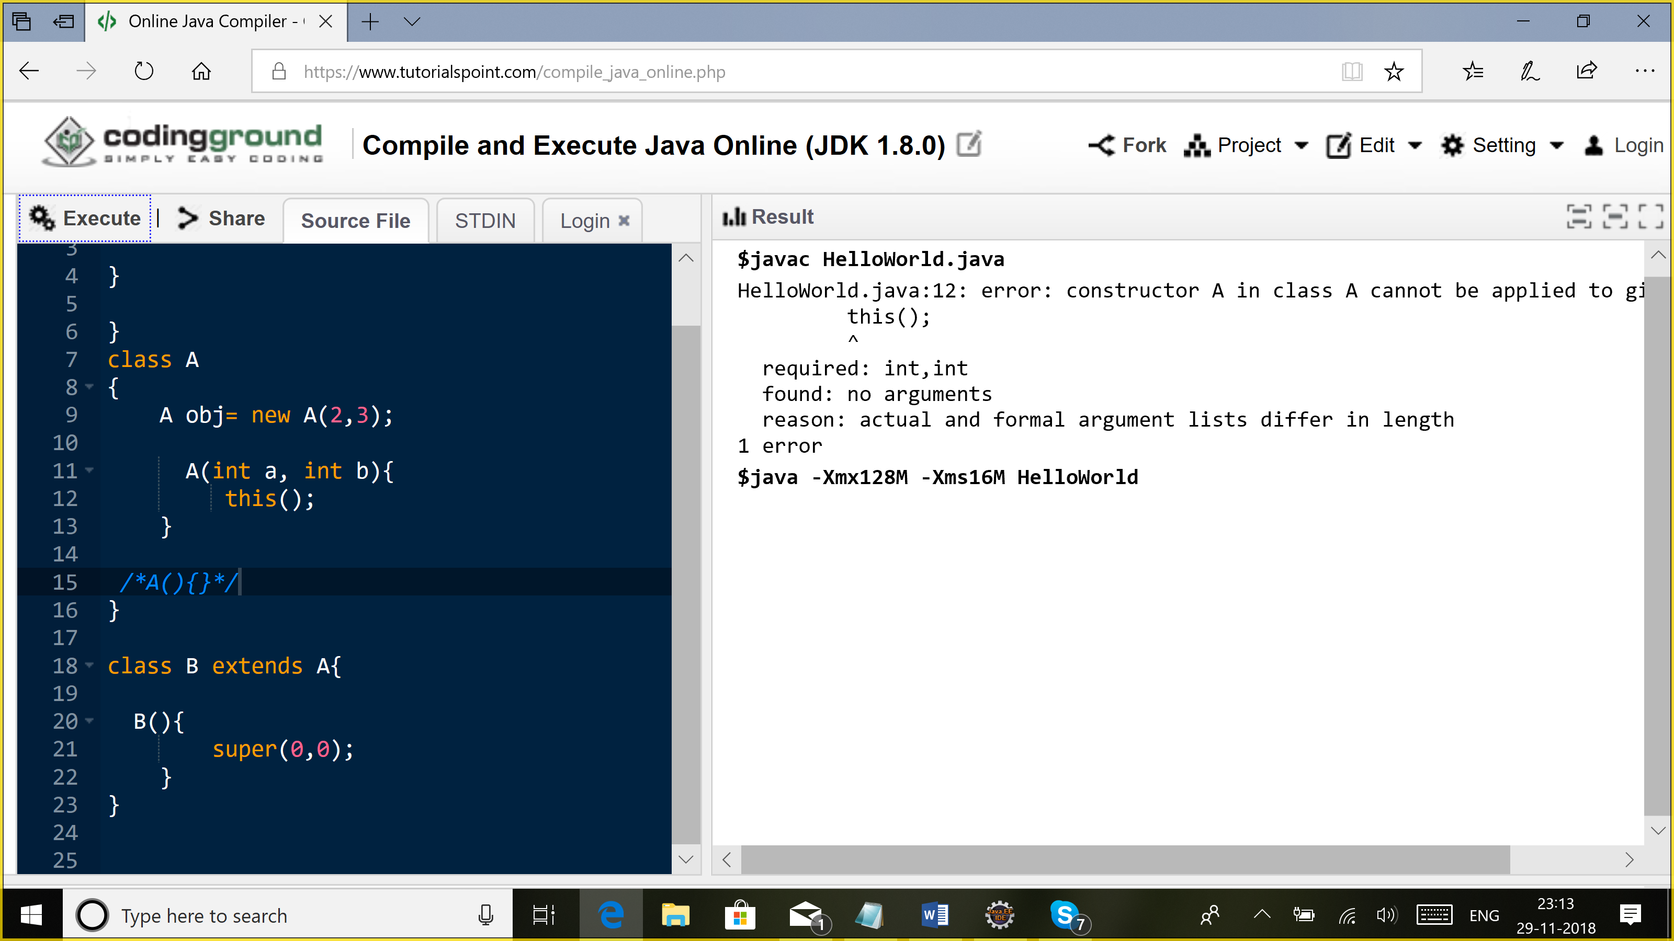

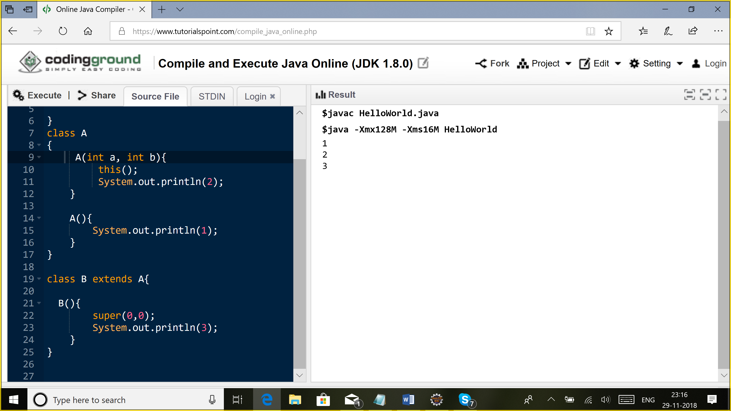

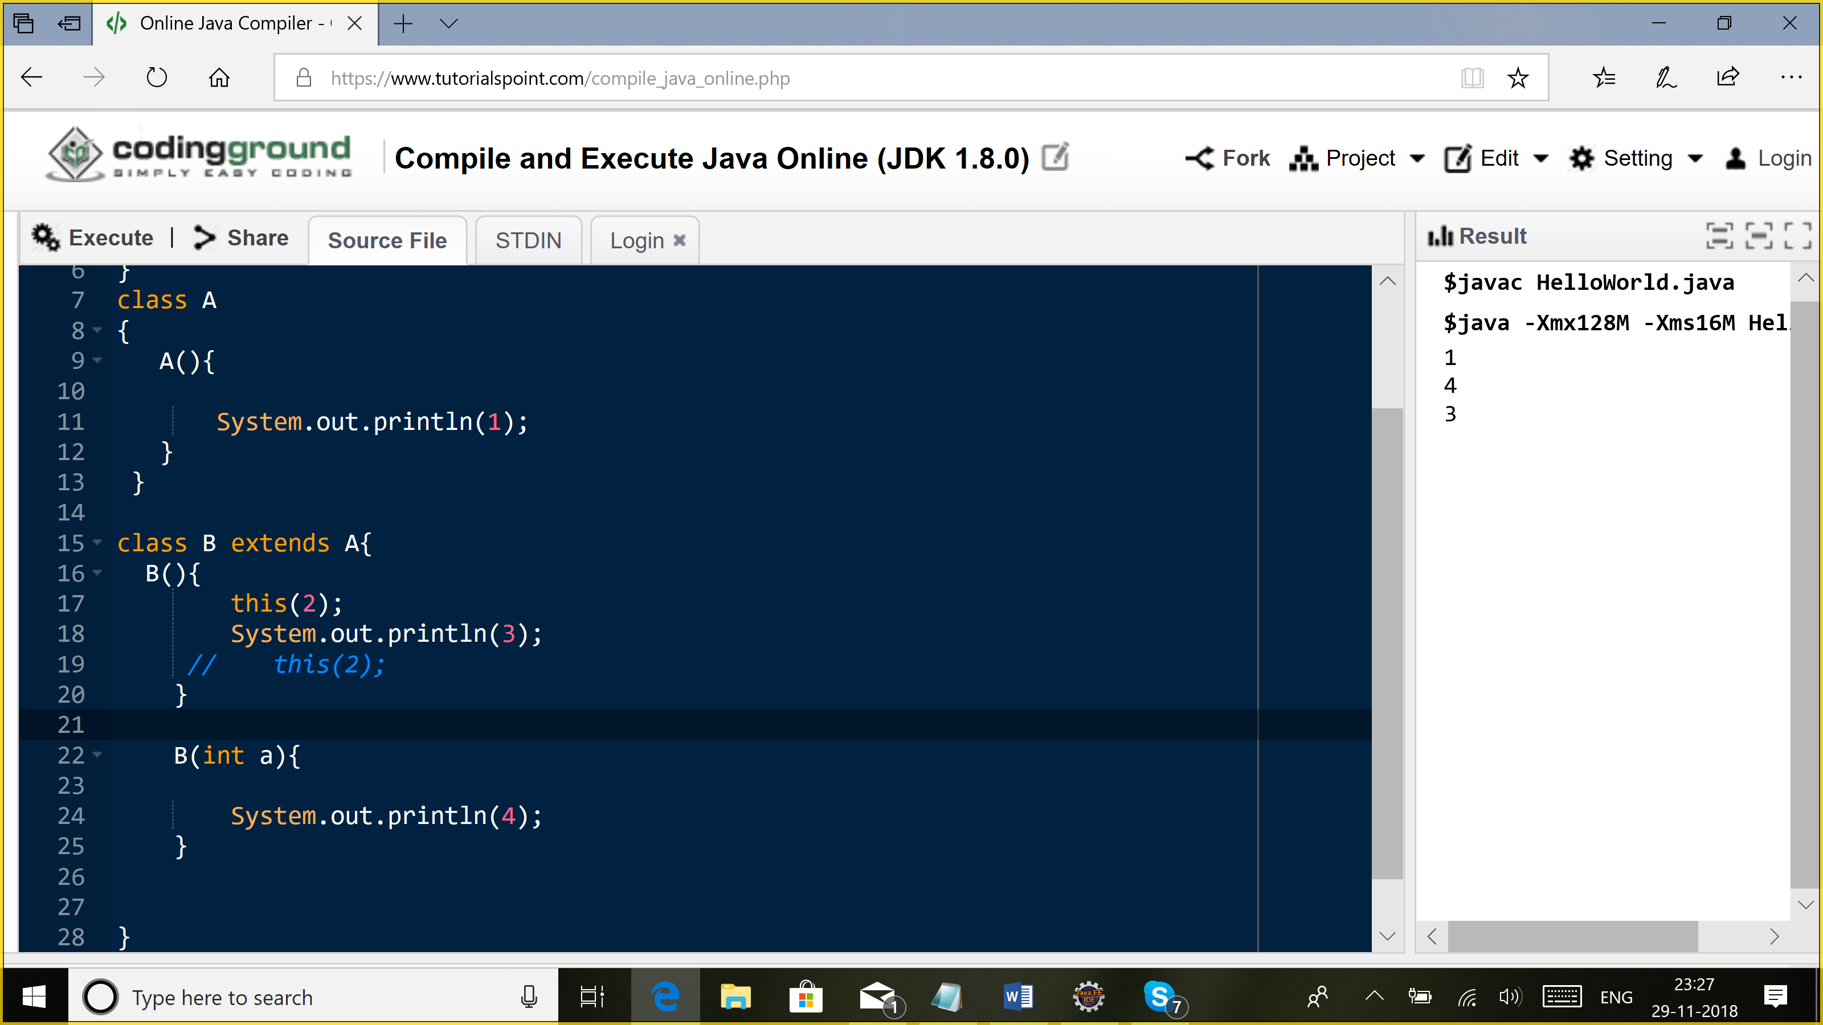

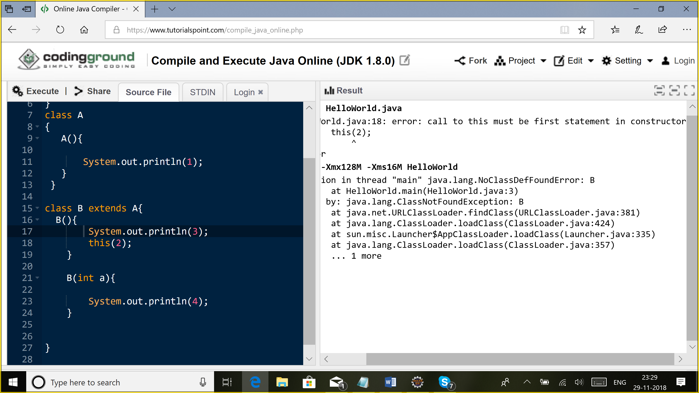

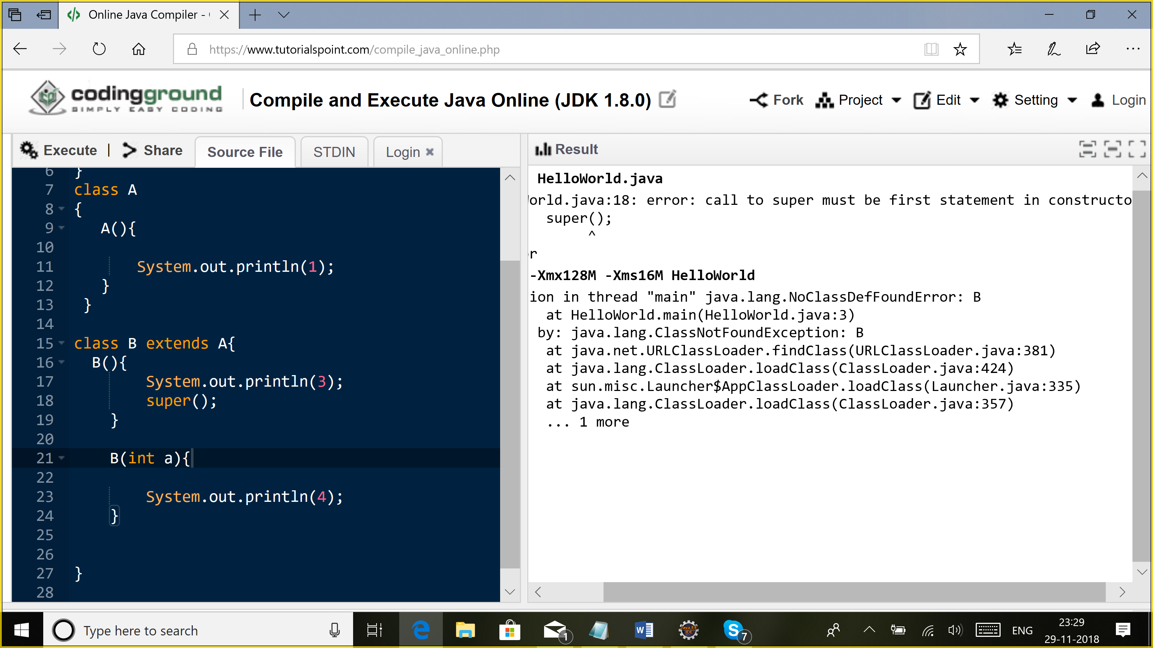

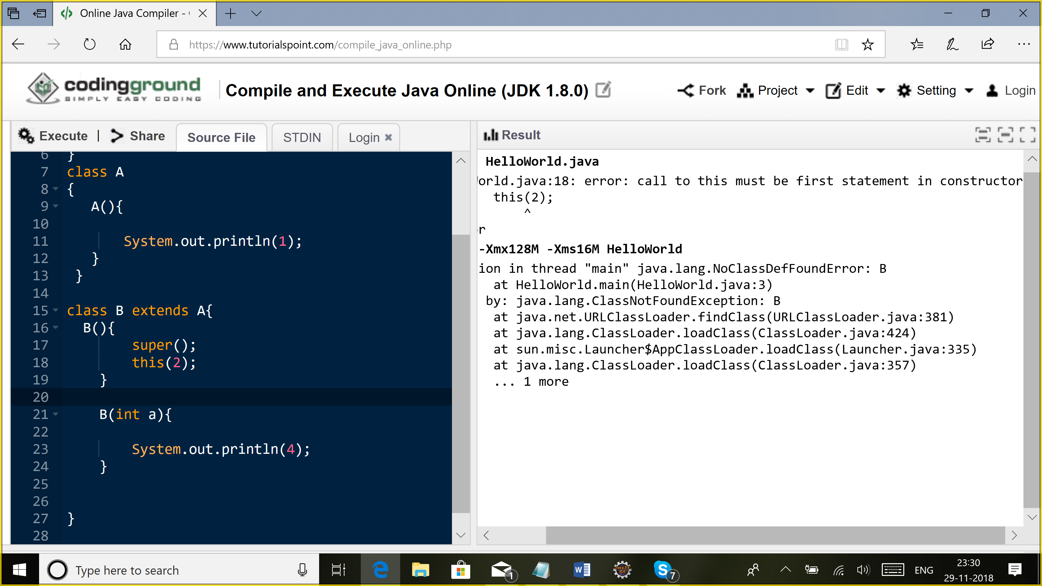

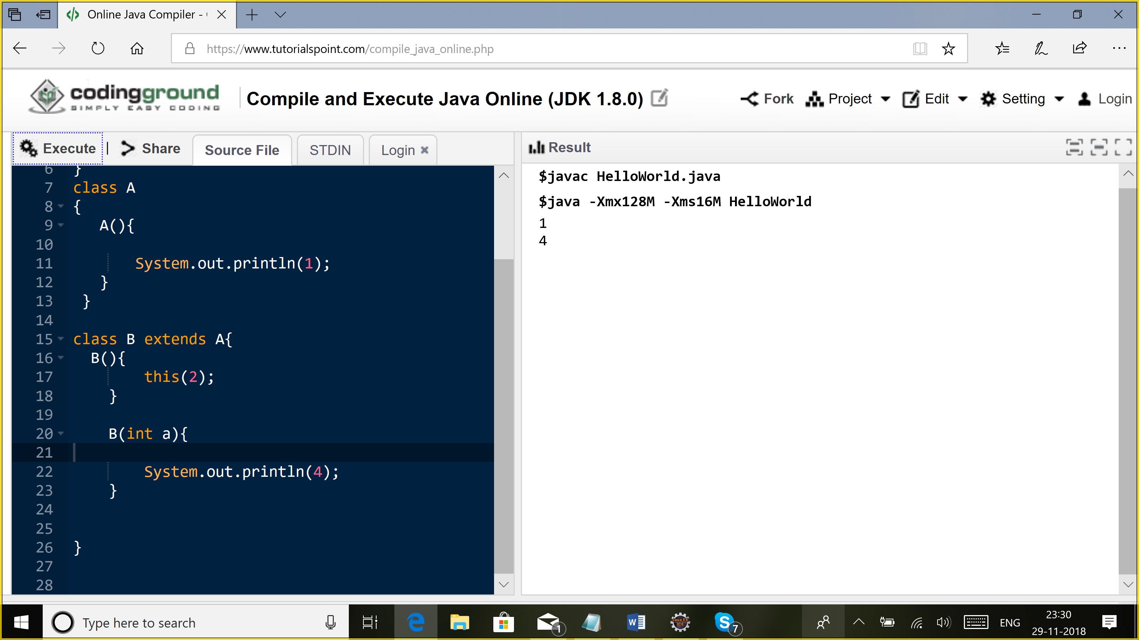

Encapsulation: data-hiding (capsule)

Class Employee{

Employee(String name){

this.name=name;

}

private String name;

private Float salary;

void setSalary(float salary){

if(salary>0){

this.salary=salary;

}

}

Class A{

Void addEmployee(Employee e){

e.name=”Puja”;

}

}